WREN HYDRAULIC TORQUE WRENCHES

DFTW SERIES

OPERATION AND MAINTENANCE MANUAL

FOR WREN 2DFTW, 4DFTW, 8DFTW, 14DFTW and 30DFTW

LOW PROFILE HYDRAULIC TORQUE WRENCHES

Series 2DFTW, 4DFTW, 8DFTW, 14DFTW and 30DFTW Low Profile Hydraulic Torque Wrenches are designed for installing and removing large bolts having minimal wrench clearance at offshore platforms, power plants, steel erection sites and other locations requiring precise high torque during bolt makeup and maximum torque for bolt breakout.

It is necessary to read and understand this Operation and Maintenance Manual when using WREN Hydraulic Torque Wrenches. The use of other than genuine WREN replacement parts may result in safety hazards, decreased tool performance, increased maintenance and may invalidate warranty.

Read this manual carefully before operating tool.

IMPORTANT SAFETY INSTRUCTIONS

IMPORTANT INSTRUCTIONS ON RECEIPT (OPEN PACKAGE INSPECTION)
Carefully inspect all components for shipping damages. If any shipping damage is found, notify the carrier at once. Shipping damage is NOT covered by warranty. The carrier is responsible for all repair or replacement cost resulting from damage in shipment.

The hydraulic torque wrench is a power tool. Read all the instructions, warnings and cautions before every operation. Comply with the safety precautions to avoid personal injury or equipment damage while operating this tool! Neither WREN, nor its distributors are responsible for damage to the tool caused by unsafe and/or faulty operations.

SAFETY FIRST!
- WARNING
To avoid personal injuries and/or equipment damages, be sure that every hydraulic component of the hydraulic torque wrench, hydraulic hose assembly and pump are rated for 10,000PSI (700kg/cm2) operating pressure.

- WARNING
To minimize the danger of overload: Always use a hydraulic gauge to indicate the working pressure. The hydraulic gauge is a window to show what is happening in the hydraulic system.

DO NOT exceed the allowable maximum torque of the hydraulic torque wrench.

- WARNING
Immediately replace any worn or damaged parts of the tool with genuine WREN replacement parts.

- CAUTION
Make sure that all the components of the tool are kept away from excessive
heat, flame, moving machine parts, sharp edges and chemicals.

- CAUTION
Avoid damage to the hydraulic hose assembly by avoiding sharp bends and kinks when routing the hydraulic hose assembly. Using a bent or kinked hose will cause severe back-pressure. Also, sharp bends and kinks will internally damage the hose leading to premature failure.

- CAUTION
DO NOT drop heavy objects, crush, or drive over the hydraulic hose assembly. A sharp impact may cause internal damage to the hose wire strands. Applying pressure to a damaged hose may cause it to rupture.

- CAUTION
Avoid high temperature exposure to the hose assembly.
Always inspect the hydraulic hose assembly for damage and wear before it is used.

- WARNING
To avoid personal injuries and/or equipment damage:
      - DO NOT:
        - Remove the shroud from the tool.
        - Modify any component of the tool.
        - Adjust the tool relief valve located inside the swivel couplings.

- CAUTION
The incorrect system connection may cause failure and injury. Before connecting the tool and hoses to the pump, make sure the tool swivel couplings, hose couplings and hydraulic pump couplings are clean.

Loose or dirty couplers will cause tool not to operate properly.

OPERATION SECTION

Reference
The Operation and Maintenance Manual of the electric or air powered torque wrench pump.

Hydraulic Torque Wrench Set Up
Connect the DFTW Power Head to the selected hex ratchet link. Then, connect the hydraulic pump and wrench with the proper twin line hydraulic hose assembly making sure all connections are proper and snug.

Preparation
1. Make certain of the size of the nut or bolt head, material, strength grade and determine the desired torque.

Appendix I, which is presented as a guideline for comparison only, gives typical torque values specified for the most commonly encountered fasteners.
Torque sequence may vary from manufacturer to manufacturer and even within individual factories, depending on the gasket material etc.

Always abide by the manufacturers/engineers procedures.

2. Determine the torque value needed and then determine the corresponding pressure of the torque wrench pump. This can be found in the Pressure -Torque Conversion Chart that was provided with the hydraulic torque wrench. You may also find this chart on the web @ www.wrentools.com

3. Inspect the hydraulic torque wrench set. Connect the hydraulic torque wrench, hose and the torque wrench pump into a hydraulic circuit. Ensure all hydraulic connections are securely connected. Verify that the hydraulic hoses are not kinked.

4. Inserting the hex ratchet links:
The low profile hex ratchet links are inserted and removed from the power head as follows:

The “hook” described by the link’s drive plate is inserted around the fixed pin of the power head and the link is swung down to rest along the base of the power head cylinder. At this point, the link pin holes of the power head and link will
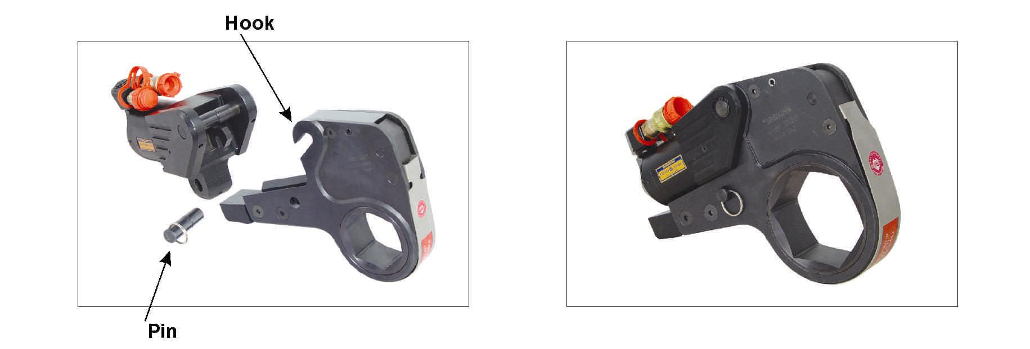
align. Insert the link pin to secure.

5. Setting for tightening or loosening the nut:
The position of the tool relative to the nut determines whether the action will tighten or loosen the nut. The power stroke of the piston rod will always turn the hex ratchet toward the shroud. The nut turns clockwise for tightening and counterclockwise for loosening.
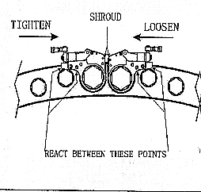

6. Connecting the wrench:
The wrench and torque wrench pump are connected by a 10,000 PSI operation pressure twin line hydraulic hose assembly.

IMPORTANT
To avoid hydraulic torque wrench malfunction:
DO NOT reverse connectors.
DO NOT tamper with the set screw in the swivel assembly. It is factory preset for safety purposes and adjustments should only be made by trained personnel.

Connect the hydraulic hose assembly to the swivel as shown below:

Insure the connectors are fully engaged and screwed snugly together.

Tool Advance Side-Male
Retract Side-Female

Hose Advance Side-Female to Female
Retract Side-Male to Male

Pump Advance Side-Male
Retract Side-Female

7. Setting the pressure on the pump:
To set the pressure on the pump, follow this procedure:
- Loosen the knurled locking ring below the “T” handle on the pump’s external pressure regulator. Then, turn the “T” handle counterclockwise (CCW) until it turns freely and easily.
- Turn the pump on. Using the pump’s remote pendant, push the advance switch (or button on the air pumps) and hold it.
- While holding the pump in the advance mode, slowly turn the “T” handle clockwise and observe the pump pressure gauge rise.
Note: Always adjust the regulator pressure UP - never down.
- When your gauge reaches the predetermined pressure, stop turning the “T” handle and let the gauge settle.
- If the pressure continues to rise above the predetermined pressure, release the back pressure slightly by turning the “T” handle CCW. Then, depress the advance switch on the remote and slowly bring the pressure up to the predetermined pressure.
- When the pressure is correct, turn the pump off and tighten the knurled lock nut, which is under the “T” handle. This sets the pump pressure, which determines torque wrench output.
- Once your target pressure is set and locked, cycle the pump once more to ensure that your pressure setting did not change as you tightened the knurled knob.
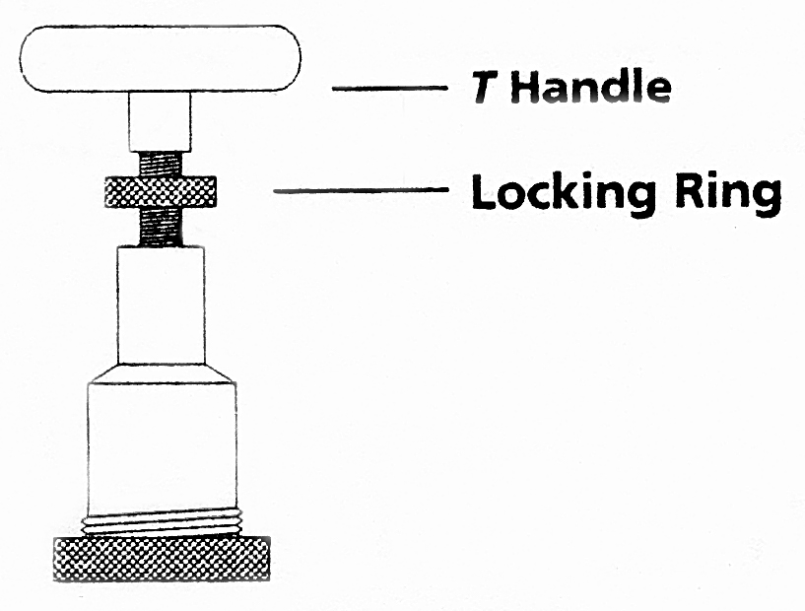

Operation
Before every operation, always read and follow the Operation Instructions.

The Tightening Process:

Operating the hydraulic torque wrench:
- Place the ratchet hex on the nut. Make certain it is the correct size for the nut and that the nut is fully engaged.
- Position the reaction surface against an adjacent nut, flange or solid system component. Make certain that there is clearance for the hydraulic hose assembly, swivels and couplings.
- Do not allow the tool to react against the hoses, swivels or couplings.
- After having turned the pump on and presetting the pressure for the correct torque setting, depress the remote control advance button to advance the piston rod. If the rod end in the piston rod did not engage the drive pin in the ratchet link when the link was joined to the housing, it will engage the pin automatically during the first advance stroke.
- When the ratchet link is connected to the power head, before the wrench is started, check to make sure all body parts are safely out of harm’s way. This tool has massive power and can cause bodily damage. The reaction surface of the wrench will move against the contact point and the nut will begin to turn. Once the piston reaches the end of its stroke, release the remote button and the tool will automatically retract the piston.
- Continue this cycling operation of advance and retract until the nut is no longer turning and the pump gauge reaches the preset pressure. The piston rod will automatically retract when the remote control button is released and the operator will hear an audible “click” as the tool resets itself.
- Continue to cycle the tool until it “stalls” and the preset PSI/torque has been attained.
IMPORTANT: The reading of full preset pressure after the cylinder is extended DOES NOT INDICATE that this pressure (torque) is applied to the bolt. It only indicates that the cylinder is fully extended and cannot turn the ratchet further until the tool automatically resets itself.

- Once the nut stops rotating, cycle the tool one last time to achieve total torque.

IMPORTANT: ALWAYS ATTEMPT ONE FINAL CYCLE TO INSURE THE “STALL” POINT HAS BEEN REACHED.

Should the hydraulic torque wrench be “locked-on” after the final cycle, push the remote control advance button once more (to build pressure) and while maintaining this pressure, push the accuracy assurance lever (located on the front of the ratchet link). Releasing the remote control advance button, while continuing to push down on the accuracy assurance lever, this will allow the tool to be removed easily.

The Loosening Process:

  - Set the pump to 10,000 PSI. Change the tool to the loosening mode, assuring the reaction surface abuts squarely on a solid reaction point.

  - Press and hold the remote control advance button down. Pressure will decrease as the nut begins to turn. As the cylinder extends fully, you will hear an audible “click”.

  - Release the remote control advance button and the cylinder automatically retracts, at which time you again hear the audible “click”.

  - Repeat this process until the fastener can be removed by hand.

NOTE: IF THE BOLT DOES NOT LOOSEN WITH THE ABOVE PROCEDURES, IT IS AN INDICATION THAT YOU REQUIRE A LARGER HYDRAULIC TORQUE WRENCH TO LOOSEN THE BOLT.

After the operation
- Upon completing the project; turn off the power to the pump, release the pressure and find the manual override button in the end of the black solenoids on the pump, push in the override button and the residual pressure will be released.

- After the hydraulic system is unloaded; disconnect all the coupler connections between wrench and hose, and then the hose and pump.

- Loosen the locking ring below the “T” handle on the pump’s external pressure regulator. Then, turn the “T” handle counterclockwise (CCW) until it turns freely and easily.

- When not in use, tools and accessories should be properly stored to avoid damage.

MAINTENANCE SECTION

Preventative Maintenance
- Lubrication
All moving parts should be periodically coated with a good quality lubricant. Under harsh environmental conditions, cleaning and lubricating should be performed more frequently.

- Hydraulic Hose Assembly
The hoses should be inspected for cracks, burns, kinks and leaks after each job. Hydraulic fittings can become plugged with dirt and should be flushed periodically.

- Connectors
Fittings should be kept clean and not allowed to be dragged on the ground or floor. Even small particles of dirt can cause the internal valves to malfunction.
- Springs
Springs are used for the drive pawl assembly and the accuracy assurance pawl. These springs can be replaced if necessary.

- Cylinder Seals
If the cylinder requires disassembly, it is recommended that the cylinder seals be replaced at the same time. Seal kits are readily available.

- Structural Members
All structural parts on the tool should be inspected periodically to determine if there are any cracks, chips or deformities. If so, immediate replacement is required.

TROUBLE-SHOOTING CHART

SYSTEM | PROBABLE CAUSE | REMEDY
Cylinder will not advance | - Couplers loose or damaged  - Dirt in direction-control valve on pumping unit  - Couplers not mated securely. | - Replace  - Disassemble and clean  - Screw together securely
Cylinder will not retract | See above | See above
Cylinder will not build up pressure | - Piston seal leaks.  - Pump coupling is broken.  - Gauge | - Replace seals  - Replace coupling  - Replace gauge
Cylinder leaks | Blow-out plug on cylinder | Replace cylinder seals and packing
Cylinder operates backwards | Disconnects are reversed on hoses, pump, or tool | Reverse disconnects on tool
Ratchet returns on retract stroke | - Broken reaction pawl  - Defective reaction pawl spring | - Replace  - Inspect, bend to original position or replace
Ratchet will not make successive strokes | - Defective drive pawl spring  - Defective drive pawl  - Cylinder is not retracting completely | - Inspect, bend to original position or replace  - Replace  - Remove tool from job, cycle freely once or twice, and replace on job
Tool cannot be removed from nut | Reaction pawl is engaged | Begin forward cylinder stroke. While applying pressure, push the reaction pawl release (on ratchet link). While pressing release mechanism, allow the cylinder to retract. Remove tool
Air Motor does not turn | - Rotor bearing frozen  - Obstruction in air valve  - Defective remote-control hose  - Defective remote button | - Inspect and replace  - Inspect and clean  - Replace  - Replace button
No pressure reading on gauge | - Gauge not tight  - Pump coupling broken  - Gauge defective  - Defective cylinder seals | - Tighten coupler  - Replace  - Replace  - Inspect and replace all cylinder seals and packing
Pump will not build up pressure | - Defective relief valve  - Air supply too low or air hose size too small  - Electric power source is too low  - Gauge  - Filter is clogged | - Inspect and replace  - Check for 100 PSI air pressure, 1” ID air hose  - Insure suitable electric power source – 25amps – 12 gauge or larger extension cord  - Replace  - Inspect and clean, or replace
Air motor sluggish or inefficient | - Dirt in air motor  - Clogged pump filter | - Flush motor with solvent  - Inspect and clean or replace
Pressure reading erratic | Defective gauge | Replace

Disassembly of the Power Head

- Make sure the tool is fully retracted.

- Apply pressure to the power head of the tool until the pressure reach 2900-4300 psi (200-300kg/cm2), then remove the rod end (#28).

- Remove the retaining ring (#12) and pull the swivel (#13) out. Inspect the three O-rings (#11) and replace.

- Remove the retaining ring (#12) and pull the swivel (#14) out. Inspect the three O-rings (#11) and replace.

- Remove the eight cylinder end cap screws (#9), tighten the jack screws (#9) to remove the cylinder end cap (#7), inspect the seals and replace.

- Pull the piston rod (#3) out of housing (#1), inspect the seals and replace.

- Remove the U-ring inside the housing (#1) and replace.

Disassembly of the Hex Ratchet Link

- Remove the two side plate top screws (#6) and the two side plate bottom screws (#7).

- Knock the roll pin (#12) and the reaction pawl spring spacer (#16) inside the side plate (#1) to remove one side plate (#1).

- Remove the inside moving parts. Remove one drive plate (#2) by knocking the two roll pins (#14) inside the drive plate (#2). Then, remove the primary drive pawl (#10) along with a compressed spring (#9) and the secondary drive pawl (#8). Remove the hex ratchet (#3) and then the drive pin (#13), along with the drive pin spring (#15).

- Remove the reaction pawl (#19), compressed spring (#9) and the reaction pawl spring spacer (#16).

Note: Refer to the exploded view drawing. For assembly, follow the instructions in reverse.

Appendix I
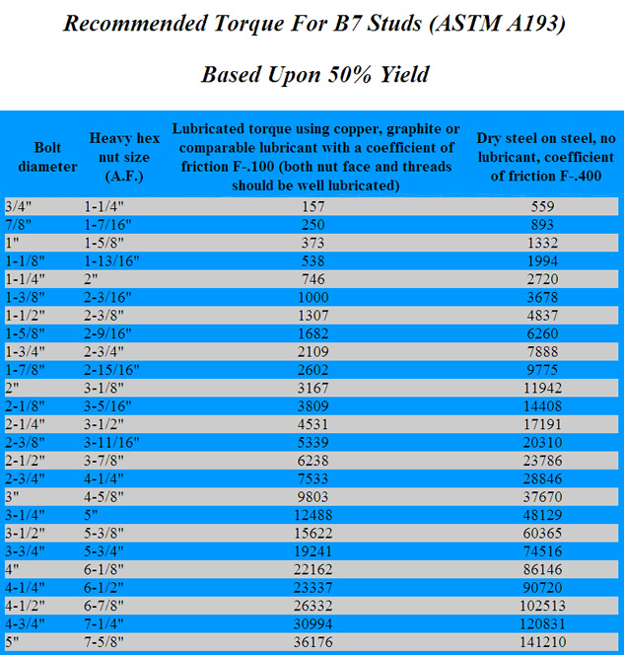
DFTW EXPLODED VIEW DRAWING

DFTW RATCHET LINK EXPLODED VIEW DRAWING

